Assignment #1: “I am from” Photo Essay Storytelling Assignment
Used in Jody Early’s BHTLH 498: Special Topics/Independent Study 2019
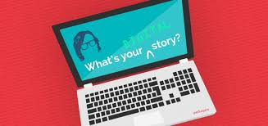

As we read about the power of digital storytelling in health promotion, let's consider your own story and how these ideas intersect with your own thoughts and lived experiences.

After reading Digital Story Cookbook, as well the SAMSHA’s Digital Storytelling Guidebook, watch the following Ted Talk as preparation for a primer assignment:

Tedtalk: The Power of Digital Storytelling by Emily Bailin ( You can fast forward to the "Where I am from...."poem at the end. This begins on the video at 13:38).

Emily's talk was based on the original "Poetry of Place" by George Ella Lyon, a poet Laureate in Kentucky, who wants to collect "Where I am from" poems across every county in Kentucky. Check out Lyon's poem and poetry http://www.georgeellalyon.com/where.html
Inspired? Now, WRITE your own " I am from...." story.
As a primer, you may wish to complete this brainstorming exercise to help you remember memories, sounds, places, etc.
http://www.theinspiredclassroom.com/docs/i%27m%20from%20idea%20gathering.pdf
Use your prose as a foundation for a short (under 3 minute; 600 words or less; 12-15 images) digital PHOTO story –which can be created by using Adobe Spark OR Powerpoint.

You will have the opportunity to share your written and photo stories with each other.

Photo stories are due by February 15th.

UW Bothell students, this assignment is due no later than Feb. 15 th our Canvas site. Post your “I am from” photo story on our designated Padlet board HERE.

Examples of BHLTH 400 Students’ “I am from” Digital Stories

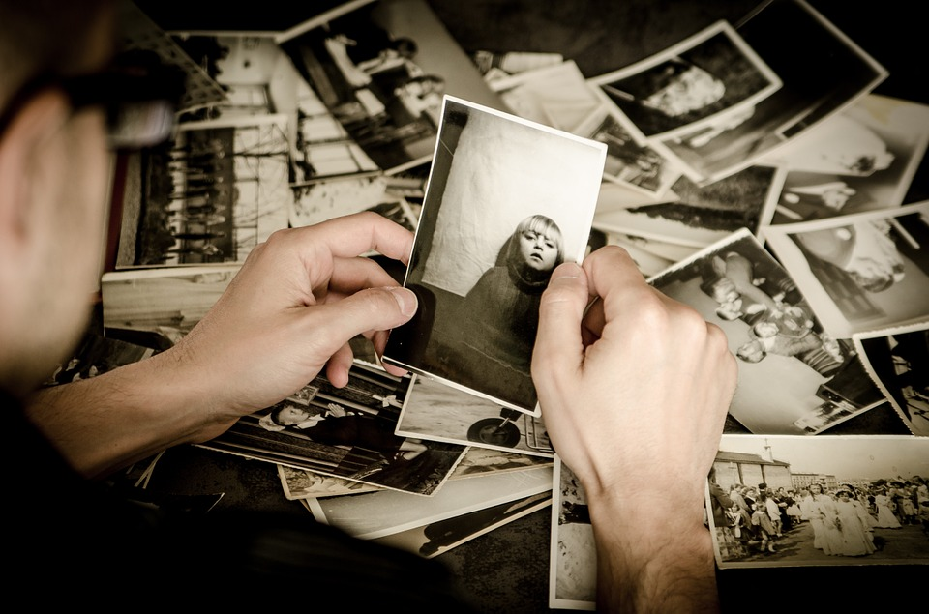

“Farmer of Hope” by Isabela Ahumada

“Where I’m from” by Sophie Knudson

“Becoming Me” By Sandy Liang

“Where I’m from” by Arjun Ram

Post Assignment (Reflective) Questions

- Identify particular course readings or class discussions that connected to the creation of your own story, either because of similarities or differences. How did these course readings/discussions help you to interpret your own story?

- Describe any emotional or intellectual transformations that you experienced in creating this story – whether in writing, in reading aloud, in selecting images or music. What do you now better understand of your own story through the process of framing it in this way? From the process of preparing this project to show to others?

- Do you think preparing and sharing your story enhanced your learning, ability to reflect, or your own self-growth in any way? Please explain.

